REPUBLIQUE DU CAMEROUN
Paix – Travail – Patrie
REPUBLIC OF CAMEROON
Peace – Work – Fatherland




BIG BLOSSOM INNOVATION TECHNOLOGY
Email: contact@bbit-it.com
Tel: + 237 655 109 309
Site Web: www.bbit.it.com
AFRICAN INSTITUTE OF COMPUTER SCIENCES PAUL BIYA TECHNOLOGICAL CENTER OF EXCELLENCE
P.O. BOX: 13719 Yaoundé
Tel: + 237 242 729 957
Web Site: www.iaicameroun.com

INTERNSHIP REPORT
DESIGN AND IMPLEMENTATION OF A WEB-BASED ERP FOR SMALL AND MEDIUM ENTERPRISES
Case Study: BBIT

Internship carried out from the 15th July to 30th September 2026
In view of obtaining a Higher Technician Diploma (HTD) in Software Engineering
Written By: ANANTIA TEMGOUA ELVADO WILFRIED
LEVEL II Software Engineering
Academic Supervisor
Mrs. ONGUENE VANESSA
Lecturer at AICS
Professional Supervisor
Mr. TCHINDEBE CHRISTIAN
CTO at BBIT

Academic Year
2025 – 2026

DEDICATION

TO MY FAMILY
TEMGOUA

ACKNOWLEDGEMENTS

SUMMARY

LIST OF FIGURES

LIST OF TABLES

GLOSSARY

ABSTRACT
Small and Medium-sized Enterprises (SMEs) play a vital role in economic development but often struggle with managing their daily operations due to fragmented or manual management systems. This project focuses on the design and implementation of a web-based Enterprise Resource Planning (ERP) system that centralizes essential business processes into a single platform.
The project was carried out during an internship at BBIT, where a modern ERP solution was developed to integrate several modules, including Employee Management, Attendance Management, Project Management, Task Management, Accounting, Customer Management, Quotation and Invoicing, Role and Permission Management, Automated Notifications, and a Decision Support Dashboard with Key Performance Indicators (KPIs).
The system was developed following standard software engineering practices, from requirements analysis to implementation and testing. The resulting application helps SMEs improve productivity, automate business processes, and make better decisions through centralized and real-time information.
Keywords:
- ERP,
- SMEs,
- Web Application,
- Business Management,
- Information System,
- Dashboard.

RESUME
Les Petites et Moyennes Entreprises (PME) jouent un rôle important dans le développement économique, mais rencontrent souvent des difficultés dans la gestion de leurs activités en raison de systèmes de gestion manuels ou non intégrés. Ce projet porte sur la conception et le développement d'un système ERP accessible via une application web, permettant de centraliser les principales opérations de l'entreprise.
Réalisé dans le cadre d'un stage au sein de BBIT, le projet intègre plusieurs modules, notamment la gestion des employés, des présences, des projets, des tâches, de la comptabilité, des clients, des devis et de la facturation, des rôles et permissions, des notifications automatiques, ainsi qu'un tableau de bord décisionnel avec des indicateurs clés de performance (KPI).
Le système a été développé selon une démarche classique de génie logiciel, allant de l'analyse des besoins jusqu'aux tests. La solution obtenue permet aux PME d'améliorer leur organisation, d'automatiser leurs processus et de faciliter la prise de décision grâce à des informations centralisées.
Mots-clés :
- ERP,
- PME,
- Application Web,
- Gestion d'Entreprise,
- Système d'Information,
- Tableau de Bor
GENERAL INTRODUCTION
Digital technologies have become essential for improving business efficiency and competitiveness. Today, many organizations rely on Enterprise Resource Planning (ERP) systems to integrate and manage their business operations. However, many Small and Medium-sized Enterprises (SMEs) still use manual methods or separate applications, resulting in inefficient workflows and poor data management. The main objective is to provide SMEs with a simple, modern, and integrated solution that improves productivity, facilitates collaboration, and supports informed decision-making.
This report is divided into two main parts:
PART I – INSERTION PHASE
This part presents BBIT, the host company, its activities, organizational structure, and the internship environment. It also describes the tasks performed and the professional experience gained during the internship.
PART II – TECHNICAL PHASE
This part focuses on the technical development of the project and is organized as follows:
- A. Existing System
- B. Specification Book
- C. Analysis Book
- D. Design phase
- E. Deployment
- F. Test of functionalities
- G. User Guide

PART I: INSERTION PHASE

Preamble
This section of the report will cover details of how we were welcomed in the host company, presentation, organization brief introduction to our project.

Content overview
INTRODUCTION
- WELCOME AND INSERTION
- GENERAL PRESENTATION OF THE COMPANY
- ORGANIZATION OF THE COMPANY
- GEOGRAPHICAL LOCATION
- BRIEF PRESENTATION OF THE PROJECT THEME
CONCLUSION

INTRODUCTION
The internship represents an important stage in a student's academic and professional journey. It provides an opportunity to apply theoretical knowledge acquired during training while discovering the realities of the professional environment. Beyond the acquisition of technical skills, an internship allows students to develop teamwork, communication, discipline, and problem-solving abilities.
This internship was carried out at BBIT SARL, a technology startup located in Yaoundé, Cameroon, specialized in software engineering, digital transformation, IT consulting, and professional training. During this period, I was integrated into the technical team, where I participated in a progressive learning process before beginning the development of my internship project, entitled "Design and Implementation of a Web-Based ERP for Small and Medium Enterprises (SMEs)." This chapter presents the company, its organization, its resources, its partners, the project team, and my integration into the company.

WELCOME AND INSERTION
I officially started my internship at BBIT SARL on Wednesday, 15 July 2026 at 8:00 AM. Upon my arrival, I received a warm welcome from the company's management and staff. The different members of the team introduced themselves and explained the company's vision, organization, internal rules, and working methodology. As a newly integrated intern, I was introduced to the development environment, the technologies used within the company, and the software development process followed by the technical team. My professional supervisor, Mr. Christian TCHINDEBE, who is one of the company's founders and Technical Director, presented the objectives of the internship and explained the expectations regarding discipline, collaboration, and continuous learning.
Unlike a traditional internship where development begins immediately, BBIT SARL emphasizes technical preparation before assigning projects. Consequently, the first weeks of the internship were dedicated to strengthening our software engineering skills. The training began with an intensive review of PHP and the Laravel Framework, which constitute the company's primary development technologies. After mastering the fundamentals of Laravel, we were introduced to software engineering best practices, particularly Clean Code principles and the SOLID Principles, which promote maintainable, reusable, and scalable software.
The next stage of the training focused on Hexagonal Architecture (Ports and Adapters Architecture) and its implementation using Laravel. Each learning module was followed by practical exercises and technical presentations during which interns demonstrated their understanding. At the time of writing this report, the training had progressed to the study of Microservices Architecture, preparing us for the development of distributed enterprise applications. This progressive learning approach enabled me to better understand modern software development practices and prepared me for the implementation of my internship project.

GENERAL REPRESENTATION OF BBIT

HISTORY
Founded in 2021, BBIT SARL is an Information Technology company located in Montée Jouvence, Yaoundé. The company was created by two Cameroonian software engineers, Mr. Bruno MAFO and Mr. Christian TCHINDEBE, both graduates of the African Institute of Computer Science (IAI).

MISSION
Initially established as a small software services company, BBIT SARL has progressively expanded its activities and has become an emerging actor in Cameroon's digital ecosystem. The company is committed to delivering innovative technological solutions while promoting digital transformation for businesses and institutions.

ACTIVITIES
Today, BBIT SARL provides four principal services:
- Web and Mobile Application Development
- Digital Transformation and Business Support
- Computer Network Installation and IT Infrastructure
- Professional Training in Information Technology and Digital Skills

VISION
The company combines technical expertise, innovation, and customer satisfaction to deliver high-quality solutions adapted to the needs of its clients. Besides software development, BBIT actively contributes to the training of future software engineers by organizing practical learning sessions and internships.

ORGANISATION OF BBIT
BBIT is administratively organized as follows:
- The Human Resources Department (HR) is responsible for recruitment, employee development, performance evaluation, administrative management, and staff welfare.
- The Technical Department is responsible for software development, system maintenance, network management, technology selection, and technical supervision of development projects.
- The Communication Department ensures both internal and external communication, promotes the company's image, and coordinates communication between different departments.
- The Digital Marketing Department develops digital marketing strategies, manages the company's online presence, and promotes its services through various digital platforms.
- The Graphics Design Department produces visual communication materials, branding elements, promotional content, and user interface designs that support the company's projects.
Figure 1 Flowchart of BBIT\

GEOGRAPHICAL LOCATION

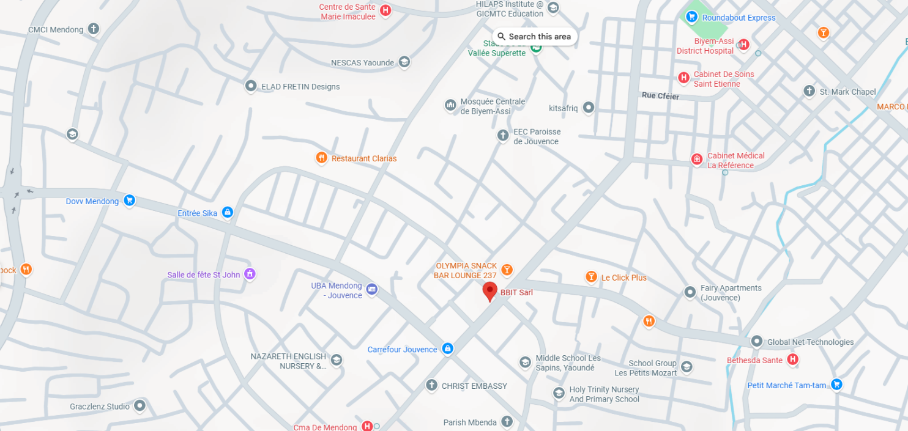
Figure 2 BBIT Location

BRIEF PRESENTATION OF THE PROJECT THEME
The project assigned during my internship at BBIT SARL is entitled "Design and Implementation of a Web-Based ERP for Small and Medium Enterprises (SMEs)." The main objective of this project is to design and develop a modern Enterprise Resource Planning (ERP) system that centralizes the management of an SME's daily operations within a single web application. Many SMEs still rely on manual processes or multiple independent applications to manage their activities, resulting in inefficiencies, data redundancy, and difficulties in decision-making.
To address these challenges, the proposed ERP integrates several functional modules, including Employee Management, Attendance Management, Project Management, Task Management, Accounting Management, Customer Management, Quotation and Invoicing Management, Role and Permission Management, Automated Notifications and Reporting, as well as a Decision Support Dashboard that provides Key Performance Indicators (KPIs) for managers.

CONCLUSION
The insertion phase allowed me to integrate successfully into the professional environment of BBIT SARL and to understand the company's organization, working methodology, and development culture. The progressive technical training provided by the company, covering Laravel, SOLID Principles, Hexagonal Architecture, and Microservices, significantly strengthened my software engineering skills and prepared me for the successful realization of my internship project. This experience established a solid foundation for the technical phase of this report, which presents the design and implementation of a Web-Based ERP System for Small and Medium Enterprises (SMEs).

PART II: TECHNICAL PHASE

Preamble
The technical phase is delved into technical intricacies of the system, focusing on the I infrastructure, security, and performance optimization to ensure a robust and efficient solution.

Content overview
INTRODUCTION
FILE I: THE EXISTING SYSTEM
FILE II: THE SPECIFICATION BOOK
FILE III: THE ANALYSIS FILE
FILE IV: THE DESIGN FILE
FILE V: THE DEPLOYMENT FILE
FILE VI: THE FUNCTIONAL TESTING
FILE VII: INSTALLATION AND USER GUIDE
CONCLUSION

INTRODUCTION
In this part of my document, we are going to give more importance to my work, that is, all the exhaustive and detailed investigation, including the mutual data collected on the existing system, which was made in order to gain good ideas on how to implement our application. Here we are going to present the existing system, make the analysis of our project, and present the application at the end, followed by the conclusion.

FILE I: THE EXISTING SYSTEM

Preamble
This section of our report will cover details of the different research did for the realization of this project. The existing study, criticism of the existing system, problem statement, proposed solutions.

Content overview
INTRODUCTION
- THEME PRESENTATION
- STUDY OF THE EXISTING SYSTEM
- CRITICISM OF THE EXISTING SYSTEM
- PROBLEMATICS
- PROPOSED SOLUTION
CONCLUSION

INTRODUCTION
Small and medium-sized enterprises (SMEs) play a fundamental role in economic development by creating employment opportunities, stimulating innovation, and contributing significantly to national economies. Despite their importance, many SMEs still rely on traditional methods, such as paper records, spreadsheets, and disconnected software applications, to manage their daily activities. As organizations grow, these methods become increasingly inefficient because information is distributed across different platforms, making communication, monitoring, and decision-making more difficult. Consequently, businesses often experience delays, data inconsistencies, poor coordination among departments, and reduced productivity. This section presents an analysis of the existing system, highlights its limitations, identifies the challenges encountered by SMEs, and introduces the proposed solution.

PRESENTATION OF THE PROJECT THEME
The theme of this project is entitled "Design and Implementation of a Web-Based Enterprise Resource Planning (ERP) System for Small and Medium-Sized Enterprises (SMEs)." The project focuses on the development of a centralized platform capable of integrating the various operations of an enterprise into a single environment. Instead of using multiple applications for employee management, accounting, project management, customer management, and invoicing, organizations will be able to perform all these operations through one unified system. The proposed platform aims to improve efficiency, facilitate communication among departments, reduce operational costs, and provide real-time access to important business information.

STUDY OF THE EXISTING SYSTEM
The study of the existing system was conducted through observations made during the internship period. It was discovered that most activities were performed manually or through the use of separate applications that were not interconnected.
Some of the major observations are presented below:
- Attendance management was carried out manually through the use of attendance registers.
- Employees recorded their names, arrival times, departure times, and signatures in a register every day.
- Employee information was stored in physical documents and spreadsheet files.
- Project and task management relied mainly on verbal communication, notebooks, and messaging applications.
- Customer information was distributed across different documents and applications.
- Reports were prepared manually, making decision-making more difficult and time-consuming.
These observations clearly reveal the limitations of traditional management methods and highlight the necessity of implementing an integrated ERP system.

CRITICISIM OF THE EXISTING SYSTEM
Table 1 Criticism of the existing system
LIMITATIONS | CONSEQUENCES | SOLUTION
Manual attendance recording | Loss of time and a higher probability of human errors | Automated attendance management
Decentralized data storage | Difficulty accessing information and duplication of records | Centralized database management
Lack of communication between departments | Poor coordination and reduced efficiency | Integration of all modules into a single platform
Manual preparation of reports | Delayed decision-making processes | Real-time reporting and analytics
Independent accounting procedures | Increased workload and inconsistencies in financial records | Automated accounting management
Manual task allocation | Difficulty monitoring employee performance | Integrated task management tools
Limited access control mechanisms | Security vulnerabilities and unauthorized access | Role-based access control
Dependence on paper documents | Document loss and increased operational costs | Digital document management
Absence of notification mechanisms | Missed deadlines and reduced productivity | Automated notifications and reminders

PROBLEMATIC
The rapid growth of business activities has increased the need for efficient information management systems. However, many small and medium-sized enterprises still lack affordable and integrated solutions capable of managing their operations effectively.
The main problem addressed by this study can therefore be formulated as follows:
How can a centralized, secure, efficient, and cost-effective web-based ERP system be designed and implemented to enable small and medium-sized enterprises to manage their business activities more effectively?
Several secondary questions also arise:
- How can data management be centralized?
- How can communication between departments be improved?
- How can administrative tasks be automated?
- How can real-time reports and performance indicators be generated?
- How can the system ensure data security and confidentiality?

PROPOSED SOLUTION
To address these challenges, this project proposes the development of a modern web-based ERP platform specifically designed for SMEs.
The proposed system integrates multiple modules into a single platform, including:
- Employee management
- Attendance management
- Project management
- Task management
- Accounting management
- Quotation and invoicing management
- Customer management
- Role and permission management
- Notification management
- Reporting and analytical dashboards
The implementation of these modules will enable organizations to improve productivity, reduce operational costs, enhance communication, and facilitate strategic decision-making.

CONCLUSION
This section examined the current management methods commonly used by small and medium-sized enterprises and identified the limitations associated with existing solutions. The analysis revealed the need for a centralized and integrated management platform capable of addressing these challenges. The proposed ERP system is intended to overcome these limitations by providing an accessible, secure, scalable, and user-friendly environment that meets the specific requirements of small and medium-sized enterprises.

FILE II: THE SPECIFICATION BOOK

Preamble
The Specification book is a document which is been established by the customer needing a particular product and the producer (engineer) who is to create the product, which is to be respected to its fullness during the realization of the product. From this, we obtain the major importance of the specification book.

Content overview
INTRODUCTION
- CONTEXT AND JUSTIFICATION
- OBJECTIVES OF THE PROJECT
- EXPRESSION OF NEEDS
- PROJECT PLANNING
- ESTIMATED COST OF THE PROJECT
- PROJECT CONSTRAINTS
- DELIVERABLES
CONCLUSION

INTRODUCTION
The specification book defines the requirements, objectives, constraints, and implementation strategy of the proposed ERP system. It serves as a reference document throughout the development process and provides a clear understanding of the project's scope. The purpose of this document is to establish the different functional and technical aspects of the system while ensuring that the final solution adequately addresses the needs of small and medium-sized enterprises (SMEs).

CONTEXT AND JUSTIFICATION

Context
In recent years, technological advancements have transformed the way businesses operate. Companies increasingly depend on digital solutions to improve communication, automate repetitive tasks, optimize productivity, and facilitate decision-making processes. However, many SMEs continue to rely on traditional methods, including spreadsheets, paper documents, and isolated applications. These approaches often result in inefficiencies, data duplication, increased operational costs, and difficulties in accessing information. To address these challenges, the development of an integrated web-based ERP system has become essential.

Justification
The implementation of this project is justified by several factors:
- The need to centralize information within a single platform.
- The necessity of reducing manual operations and human errors.
- The need to improve communication between departments.
- The importance of obtaining reliable information in real time.
- The requirement for a secure and scalable management system.
- The need to provide an affordable ERP solution specifically designed for SMEs.

OBJECTIVES OF THE PROJECT

General objective
The general objective of this project is to design and implement a secure, scalable, and user-friendly web-based ERP system capable of integrating the principal business activities of small and medium-sized enterprises.

Specific Objectives
The specific objectives of the project are as follows:
- Develop a centralized employee management module.
- Implement an automated attendance management system.
- Create a project management module.
- Design a task management system.
- Develop an accounting management module.
- Implement quotation and invoicing functionalities.
- Create a customer relationship management module.
- Develop dashboards and analytical tools.
- Implement role-based access control mechanisms.
- Integrate notification and reporting functionalities.
- Ensure the security and reliability of the platform.

EXPRESSION OF NEEDS

Functional Needs
The system must be capable of performing the following functions:
- User authentication and authorization.
- Employee registration and management.
- Attendance management.
- Project and task management.
- Invoice and quotation management.
- Customer management.
- Accounting operations.
- Report generation.
- Dashboard visualization.
- Notification management.

Non-Functional Needs
The application must satisfy the following requirements:
- High performance.
- Data security.
- Reliability and availability.
- Scalability.
- Ease of use.
- Maintainability.
- Compatibility with different devices and operating systems.

PROJECT PLANNING

Chronogram of Activities
Table 2 Chronogram of Activities
Phases | Objectives | Output | Duration
Insertion phase | Become familiar with the company, understand the working environment, and identify the problems encountered by the organization. | Internship report notes, observations, and initial requirements. | 15 July – 21 July  (1 week)
Requirement analysis | Identify user requirements and define the functional and non-functional requirements of the system. | Requirement specification document. | 22 July – 4 August  (2 weeks)
System design | Design the system architecture, user interfaces, database structure, and UML diagrams. | Database schema, diagrams, and interface prototypes. | 5 August – 18 August  (2 weeks)
Development | Implement the various modules of the ERP system and integrate all components into a single platform. | Functional ERP application. | 19 August – 15 September  (4 weeks)
Testing | Identify, analyze, and correct errors while improving system performance. | Tested and optimized application. | 16 September – 22 September  (1 week)
Deployment | Configure and deploy the system in the production environment. | Operational and deployable application. | 23 September – 26 September  (4 days)
Final documentation | Improve the system, correct remaining errors, and finalize the internship report. | Final version of the report and application. | 27 September – 30 September  (4 days)

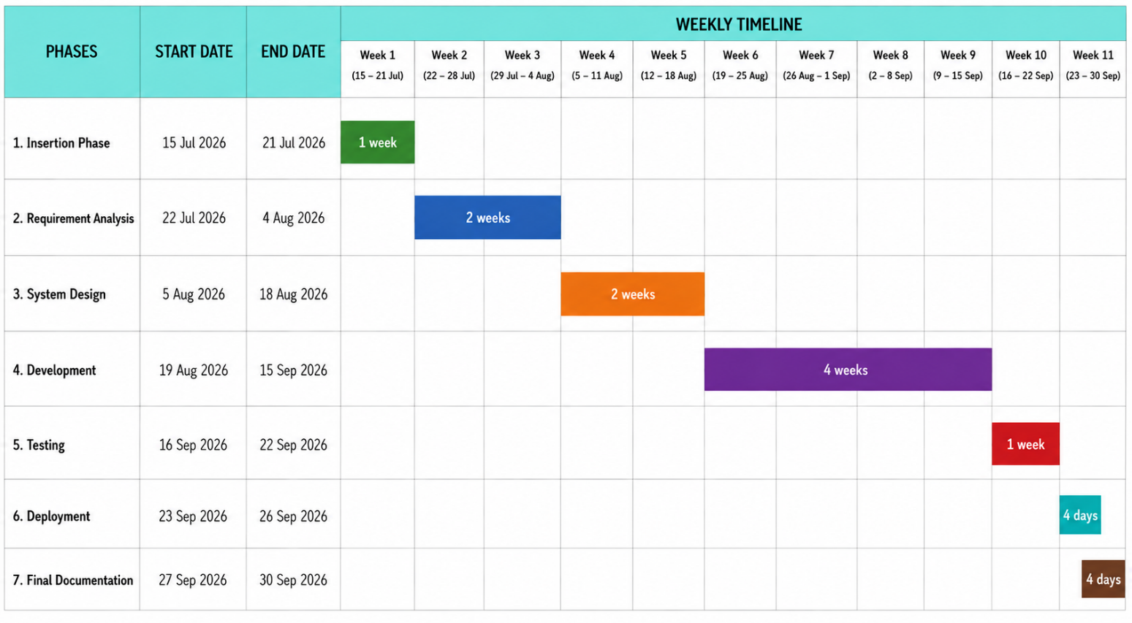
Gantt Project Planning
Figure 3 Gantt Chart

ESTIMATED COST OF THE PROJECT

Software Resources
Table 3 Software Resource of the project
Resource designation | Usage | Quantity | Unit cost (FCFA)
Laravel | Backend development | 1 | Free
React | Frontend development | 1 | Free
PostgreSQL | Database management | 1 | Free
Supabase | Database hosting and authentication | 1 | Free
GitHub | Version control and source code management | 1 | Free
Google Chrome | Application testing | 1 | Free
Visual Paradigm | UML diagrams and system design | 1 | Free
Visual Studio Code | Source code editing | 1 | Free
Composer | PHP dependency management | 1 | Free
Node.js | JavaScript runtime environment | 1 | Free
NPM | Package management | 1 | Free
Postman | API testing | 1 | Free
AWS (free tier) | Application deployment | 6 months | Free
Microsoft Word | Report writing and documentation | 12 months | 45,000
TOTAL |  |  | 45,000

Hardware Resources
Table 4 Hardware Resources of the project
Resource designation | Usage | Quantity | Unit cost (FCFA)
HP Victus laptop | Software development | 1 | 550,000
External mouse (Dell) | Navigation and development | 1 | 5,000
USB flash drive | File storage and backup | 1 | 5,000
Database server | Cloud data storage | 1 month | Free
AWS server (free tier) | Application hosting | 6 months | Free
Internet subscription | Communication and development activities | 3 months | 75,000
TOTAL |  |  | 635,000

CONSTRAINTS

1. Budget Constraint
The budget constraint concerns the financial resources available for the development and deployment of the application. Since this project is carried out within an academic context, the objective is to minimize development costs by relying mainly on free or open-source technologies.
The main budget considerations include:
- The use of free development tools and frameworks such as Laravel, React, and open-source libraries.
- The possible costs related to hosting, database deployment, and domain registration if the application is made available online.
- The cost of any additional services or software required during the development phase.
The project will therefore prioritize cost-effective solutions while ensuring good performance, security, and maintainability.

2. Time Constraint
The time constraint refers to the limited period allocated for the analysis, design, development, testing, and documentation phases of the project.
The main challenges related to time include:
- Completing all development phases within the scheduled academic calendar.
- Ensuring that the essential functionalities of the ERP application are implemented before the deadline.
- Allocating sufficient time for testing, debugging, documentation, and preparation of the final presentation.
To address this constraint, the project will follow a structured development methodology with clear planning and prioritization of the most important features.

3. Technical Constraint
The technical constraint concerns the technological limitations and requirements that may affect the implementation of the application.
These constraints include:
- Ensuring compatibility between the chosen technologies (Laravel for the backend and React for the frontend).
- Managing the complexity of developing an ERP system that integrates multiple modules such as user management, inventory, sales, and reporting.
- Ensuring data security through authentication, authorization, and protection against common vulnerabilities.
- Designing an application that can evolve and support future improvements.
- Working within the available hardware and software resources during development.

DELIVERABLES
At the end of the project, several deliverables will be provided to demonstrate the completion and functionality of the developed solution.
1. Dissertation Report
2. Application
3. User Guide
4. Source Code Repository
5. PowerPoint Presentation

CONCLUSION
This specification book has allowed the definition of the main aspects of the project, starting from the identification of the problem and the objectives to be achieved, up to the functional and technical requirements of the proposed solution. It has provided a clear understanding of the needs of the users, the expected functionalities, the technological choices, the project constraints, and the deliverables that will be produced at the end of the development process. Through this document, the scope of the project has been clearly established, serving as a reference framework for the design, implementation, and evaluation phases. The identified requirements will guide the development of the ERP application to ensure that the final solution meets the expectations in terms of usability, performance, security, and scalability. Therefore, this specification book represents an essential foundation for the successful realization of the project, reducing uncertainties and providing a structured approach for the development of a reliable management solution adapted to the needs of small and medium-sized enterprises.

FILE III: THE ANALYSIS FILE

Preamble
The main objective of the analysis phase is to capture the user's need, the delimitation of the field of study, and to have a clear understanding of the system in study. To achieve this, we will use UML (Unified Modelling Language) and 2TUP (2 Track Unified Process) as a method applied to UML to analyze the system. We will start by doing a comparison between UML and Merise, of various unified processes, and lastly, we will present the modeling of the solution we propose in Bracket our software.

Content overview
INTRODUCTION
- METHODOLOGY
  - Comparative study of UML and Merise
  - Comparative study of Unified Processes
  - Justification of the method of analysis
- MODELLING OF THE PROPOSED SOLUTION
CONCLUSION

INTRODUCTION
The analysis book permits us to examine in an explicit way the existing system, it’s limitations and how we can remedy them. We will also describe in details the modeling language known as UML (Unified Modeling Language) which is coupled with Two Tract Unified Process (2TUP) to form a method and its justification why we decided to use it in preference of another. then we will dive directly into the modeling of the proposed solution consisting of diagrams that meets the requirements of the functional needs.

PRESENTATION OF THE ANALYSIS METHOD

Comparative study of UML and MERISE

Modeling with Merise
MERISE stands for “Méthode d’Etude et de Réalisation Informatique pour des Systèmes d’Entreprise”. Although it is prescriptive to some extent, MERISE permits the participation of end users and senior management as well as data processing professionals in its decision cycle. MERISE is a method for designing, developing and carrying out IT projects. The goal of this method is to achieve the design of an information system. The MERISE method is based on the separation of data and processing to be carried out in several conceptual and physical models. The essentials of the approach lie in its three cycles: the decision cycle, the life cycle and the abstraction cycle, which cover data and process elements equally. The separation of data and processing ensures longevity in model. Indeed, the arrangement of data does not have to be often overhauled, while treatments are more frequently

Modeling with UML
The unified modeling language (UML) is a general purpose, developmental modeling language in the field of software engineering that is intended to provide a standard way to visualize the design of a system. The Unified Modeling Language (UML) was standardized in January 1997 by the Object Management Group (OMG) which is an American association created in 1989 and aims to promote and standardize the object model in all its forms. In 2005, UML was also published by the international organization for standardization (ISO) as an approved ISO standard. UML since 2015 is in its version 2.5. This version consists of fourteen diagrams classified into structural and behavioral diagrams

Static or Structural Diagrams
Structural diagram represents the static components of a system; they emphasize on what should be in the system we are modeling. They include:
- Class diagram
- Object diagram
- Package diagram
- Composite diagram
- Deployment diagram
- Component diagram
- Profile diagram

Behavioral or dynamic diagrams
The behavioral diagrams capture the dynamic state of a system, they emphasize on what should happen in the system we are modeling, they are:
- Use case diagram
- Activity diagram
- State machine diagram
- Sequence diagram
- Communication diagram
- Interaction overview diagram
- Timing diagram

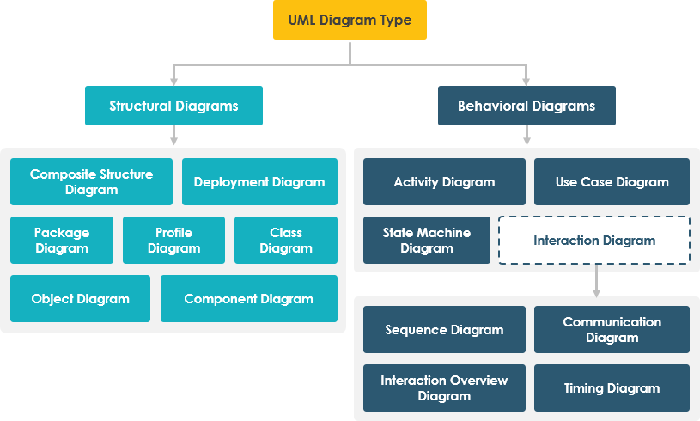
UML 2.5 Diagrams Overview
Figure 4 UML Diagrams

It is important to note that UML is a modeling language and not a method or procedure. Hence, to give it an approach, we need to associate UML to a Unified process (UP) in order to give our conception a methodology to follow. A unified process is a generic method for developing software. This implies it is necessary to adapt the UP to the context of the project, team domain and or the organization. We will use the Two Tracks Unified Process (2TUP) throughout our project to implement our solution.
Table 5 Difference between UML and MERISE
MERISE | UML
It stands for Méthode d'Étude et de Réalisation Informatique pour les Systèmes d'Entreprises | Unified Modelling Language
MERISE is a systemic method of analysis and design of information systems. That is, it uses a systems approach. | UML is however not a method but rather an object modelling language to which it is necessary to associate an approach to make it a method. This is the case with the 2TUP method; RUP and XP.
MERISE proposes to consider the real system from two points of view:  - A static view (data)  - A dynamic view (treatments).  That is, with the MERISE method, we have a separate study of the data and the treatments. | UML offers a different approach from that of MERISE in that it combines data and processing. Because with UML, centralizing the data of a type and the associated processing makes it possible to limit the maintenance points in the code and facilitates access to information in the event of software development. In addition, UML describes the dynamics of the information system as a set of operations attached to the objects of the system.
Rational | Object

Comparative Study of Unified Processes
A process can be defined as a partially sequence of steps that permits us to obtain software systems or evolution of an existing one. The main objective of software development is the production of quality software that response to the needs of the users during a particular time and at a particular cost.

Unified Process
A unified Process is a process of development of software constructed on UML; it is iterative, incremental, centered on architecture, driven by use cases and requirements.
- Iteration is distinct sequence of activities with a basic plan and evaluation criterion that produces an internal or external output. Either the content of an iteration is improved or the evolution of the system is evaluated by users.
- An increment is the difference between two released products at the end of two iterations. Each iteration that the group is capable of integrating the technical environment in order to develop a final product and give users the possibility of having tangible results.
- Centered on architecture the different models derived during the establishment of system must be reliable and coherent.
- Driven by use case and requirements enables the clear definition of a users’ needs and priorities respectively thereby minimizing the risk of project failure.

The Two Track Unified Process
2TUP is a unified process which is belt on UML and has as objective to bring solution to constraints of functional and technical changes imposed on information systems by strengthening controls on development capacities. It proposes a Y-sharped development life cycle that separates the functional aspect from the technical aspects, and the merging of these two forms the implementation aspect. 2TUP distinguishes therefore two branches: the functional and technical branches, the combination of the result of these two branches forms the third: the realization branch where we realize our system. The diagram bellow illustrates the branches of 2TUP.

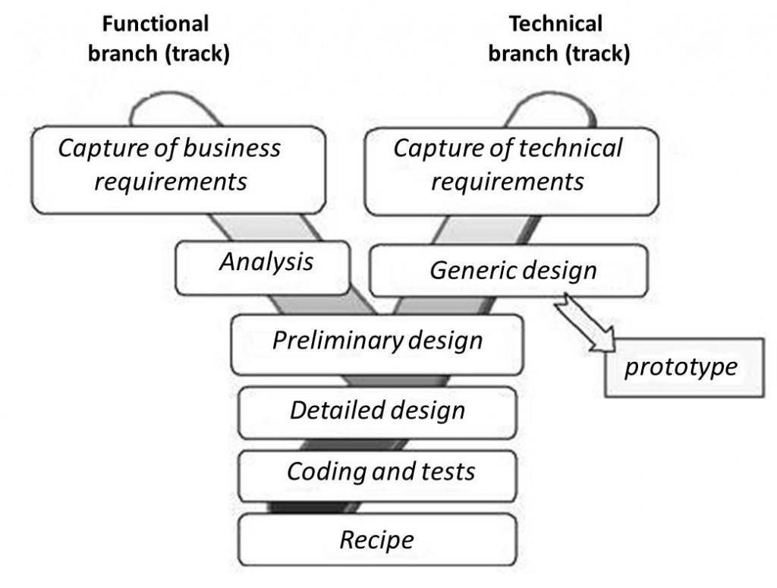
Figure 5 Two Track Unified Process

a. The left branch (functional branch)
It captures the functional needs of a system. This ensures the production of software that meets the needs/requirements of the user. The analysis here consists of studying precisely the functional specification in order to obtain an idea of what the system is going to realize, and its result does not depend on any technology.

b. The right branch (Technical branch)
The technical branch enumerates the technical needs and proposes a generic design validated by a prototype. The technical needs include constraints and choices related to the conception of the system, the tools.

c. The middle branch (Realization or Implementation branch)
In this branch, we study the preliminary conception, detailed conception, and documentation of the system. The realization branch supports the following:
Preliminary conception: This is the most sensitive step of 2TUP as it is the confluence of the functional and technical branch. It is completed when the deployment model, the operating model, the logical model, interphases and the software configuration model are defined. We have the following diagrams:
- Component Diagram
- Deployment Diagram
- Package Diagram
- Composite Structure Diagram
Detailed conception: This is the detailed design of each feature of the system. We have the following diagrams:
- Class
- Sequence
- Object
- Timing diagram
Coding and testing: This is the phase where we program the designed features and test the coded features.
The recipe: Also known as, the deliverables is the validation phase of the functions of the developed system.

Justification of the method of analysis
The reason why we chose UML modelling language and the software development process 2TUP instead of many others that exist, include:
- UML is the current standard for programming in an object-oriented language. For this reason, it is widely understood and well known making it easy for a new programmer to join the project and be productive from the very first day.
- UML diagrams allow teams to visualize how a project is or will be working, and they can be used in any field, not just software engineering. The diagrams will allow teams to visualize together how a system or a process will work or did work. It can provide new ideas for how teams must collaborate to achieve the goal of the work-flow process.
- 2TUP is centered around the creation and maintenance of a model, rather than the production of mountain documents. 2TUP is user oriented as it permits the development of software that responds to the needs of the users through the study of the user needs.
- 2TUP is iterative and incremental, hence it enables the project team to produce refined amelioration if necessary and easily integrate it in the already existing system. 2TUP by permitting the project team identify and test the key functionalities of the system limits the risk related to building the system.

MODELLING OF THE PROPOSED SOLUTION

Use case Diagram

Definition
Use-case diagrams describe the high-level functions and scope of a system. These diagrams also identify the interactions between the system and its actors. The main objectives of the use case diagram are:
- Provide a high-level view of the system.
- Identify the functions of the system.
Use case diagrams are completed with a textual description of each use case that is intended to define the use case in details.

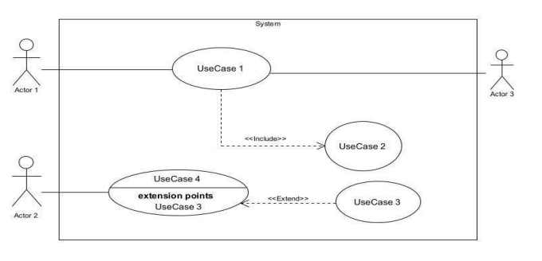
Formalism

Elements
Figure 6 Use case diagram formalism
Table 6 Use case diagram component
Elements Notation Description
Actors | 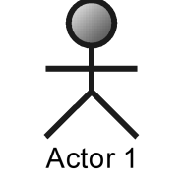 | Represents an entity that directly interacts with the system. The actor is what performs the different possible actions of the system
Use case | 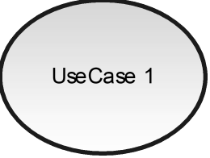 | A use case represents a functionality of the system. An actor can perform an action.
Association | 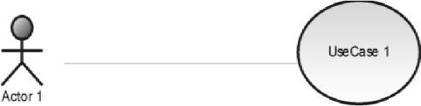 | It indicates that an actor takes part in a use Case.
Include | 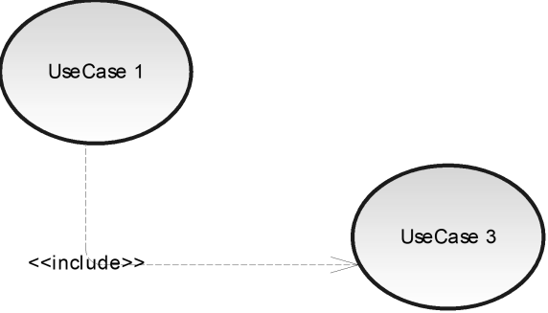 | An inclusion denotes that an included action must be performed before the including action can be performed
Extend | 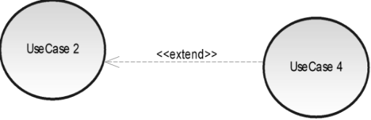 | An extension denotes that an extending action may be performed while an extended action is being performed.
Generalization | 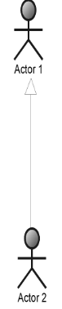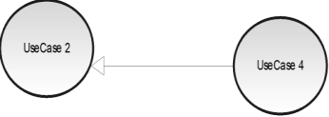 | This shows that an actor or a use case is a kind of another abstract or concrete actors can be defined and later specialized using
System | 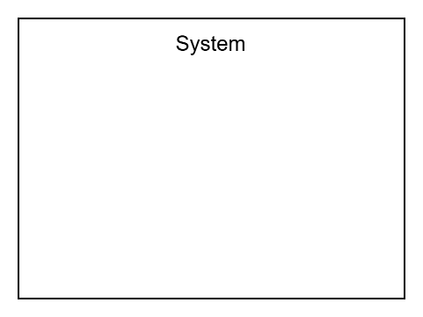 | It is a container of use cases which interact with external actors

Actors of the system
Primary Actors
Table 7 Primary actors of the system
Actor | Description
Visitor | Registers and accesses the ERP system.
Employee / Intern | Manages personal information, tasks, attendance, and receives notifications.
Project Manager | Manages projects, assigns employees, and manages the Kanban board.
HR Manager | Manages employees, monitors attendance, generates attendance reports, and views the dashboard.
Admin | Manages system users, assigns roles, and generates QR codes.
Customer | Buys goods or services.
Accountant | Manages the different customers, track company finance.

Secondary Actors
Table 8 Secondary actors of the system
Actor | Description
Claude AI API | Processes users' prompts and provides AI-generated responses.
SMTP Server | Sends email notifications to system users.
Payment API | To make payments easily.

General use case diagram
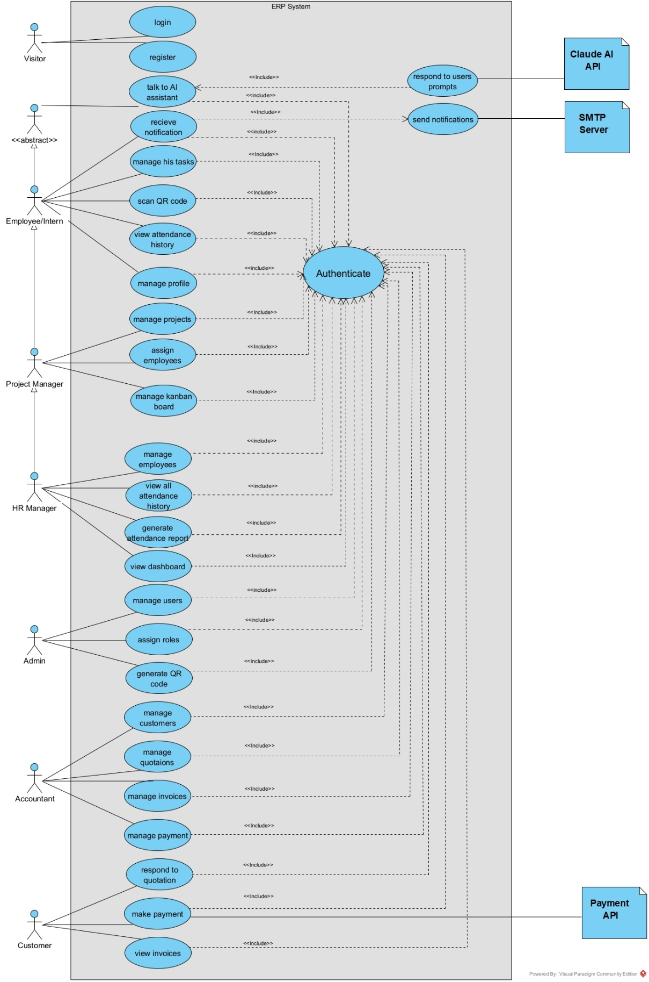
Figure 7 General use case diagram

Specific use case diagrams
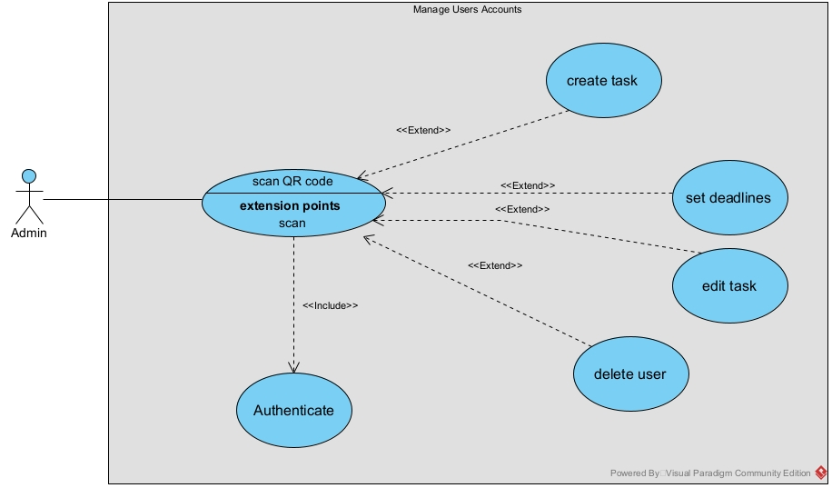
Figure 8 manage users accounts
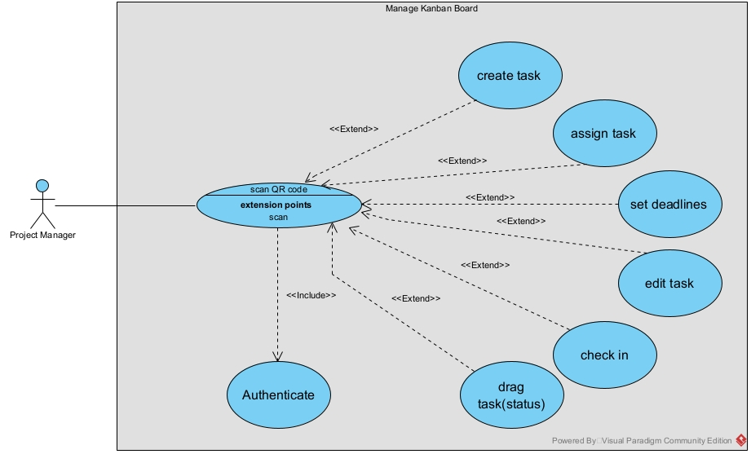
Figure 9 manage kanban board

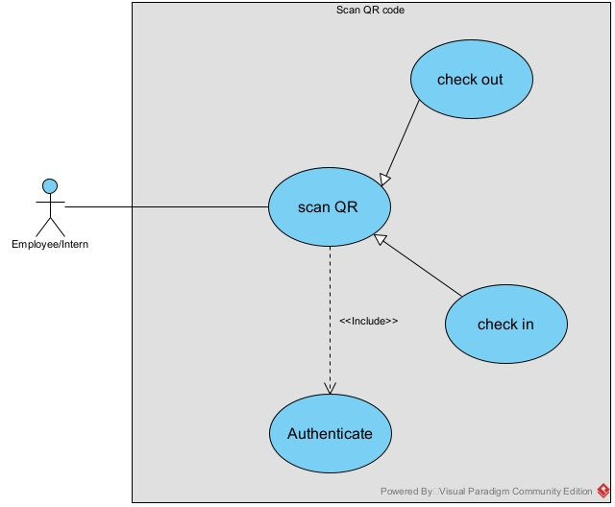
Figure 10 scan QR code
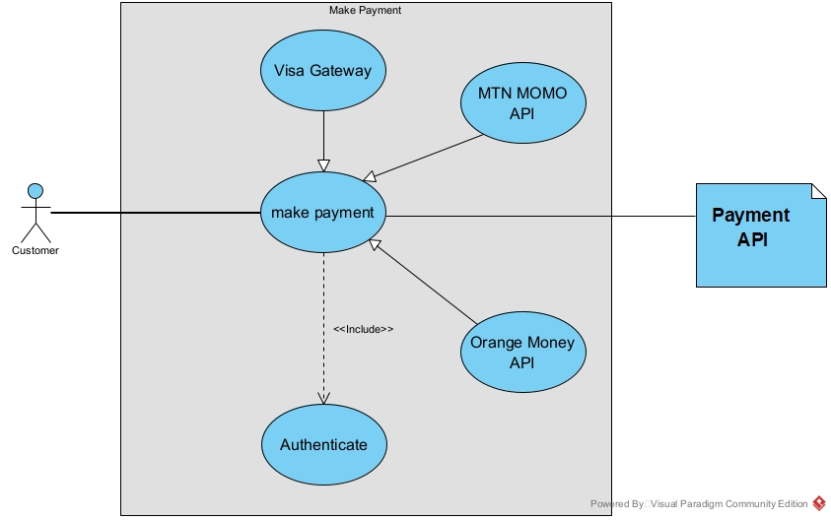
Figure 11 make payment

Description of use cases
The description of a use case is done by scenarios that describe the logical sequence of action that constitute this use case.
- Textual Description of authenticate
Table 9 textual description of authenticate
Title | Authenticate
Summary | The authentication use case allows an authorized user to access the ERP system using their login credentials.
Actor | Employee / Intern
Date | 09/08/2026
Stakeholders | Employee/Intern, Human Resources Manager, System Administrator
Version | 1.0
Precondition | The user must have a valid account registered in the system and must have access to the login page.
Trigger | The user enters their email/username and password and submits the login form.
Normal Scenario | 1. The user opens the login page.  2. The user enters their email/username and password.  3. The user submits the login form.  4. The system verifies the provided credentials.  5. The system authenticates the user.  6. The system retrieves the user's role and permissions.  7. The system redirects the user to the appropriate dashboard.
Alternative Scenario | 4.A If the credentials are incorrect, the system displays an error message and asks the user to enter them again.  4.B If the account is inactive or disabled, the system denies access and informs the user.  4.C If the account does not exist, the system displays an authentication error and prevents access.
Post Condition of Success | The user is successfully authenticated and gains access to the ERP functionalities permitted by their role.
Post Condition of Failure | The user remains unauthenticated and cannot access protected functionalities of the system.
Non-Functional Requirement | The authentication process shall be secure and reliable. User credentials shall be protected, and the system shall respond to login requests within an acceptable time.

- Textual description of Scan QR code
Table 10 textual description of scan QR code
Title | Scan QR code
Summary | The scan QR code use case allows an employee or intern to record their attendance by scanning a QR code for check-in or check-out.
Actor | Employee / Intern
Date | 09/08/2026
Stakeholders | Employee/Intern, Human Resources Manager, System Administrator, External QR Code Provider
Version | 1.0
Precondition | The employee/intern must have a valid account and must be authenticated. A valid QR code must be available from the external QR code provider.
Trigger | The employee/intern scans the available QR code using the attendance functionality of the ERP.
Normal Scenario | 1. The employee/intern accesses the QR code scanning functionality.  2. The system activates the QR code scanner.  3. The employee/intern scans the QR code provided by the external QR code provider.  4. The system reads and validates the QR code.  5. The system authenticates the user.  6. The system determines whether the scan corresponds to a check-in or check-out.  7. The system records the attendance event with the user's identity, date and time.  8. The system displays a confirmation message indicating that the attendance has been successfully recorded.
Alternative Scenario | 3.A If the QR code cannot be scanned, the system asks the user to try scanning again.  4.A If the QR code is invalid or expired, the system rejects the scan and displays an appropriate error message.  4.B If the QR code is not recognized by the system, the attendance operation is cancelled.  5.A If the user cannot be authenticated, the system denies the attendance operation.  7.A If the user has already recorded the same attendance type for the relevant period, the system prevents the creation of a duplicate record.
Post Condition of Success | A valid attendance record is stored in the system with the employee/intern's identity, date, time and attendance type (check-in or check-out).
Post Condition of Failure | No attendance record is created and the user is informed that the attendance operation could not be completed.
Non-Functional Requirement | The QR code scanning process shall be fast, reliable and secure. Attendance data shall be recorded accurately, and the system shall prevent unauthorized access or modification of attendance records.

- Textual description of manage task using kanban board
Table 11 textual description of manage kanban board
Title | Manage task
Summary | The Manage Tasks use case allows authorized users to create, assign, organize, update and monitor project tasks through a Kanban board.
Actor | Project Manager / Employee
Date | 09/08/2026
Stakeholders | Project Manager, Employee/Intern, Human Resources Manager, System Administrator
Version | 1.0
Precondition | The user must be authenticated and have the required permissions to access and manage project tasks. A project must exist in the system.
Trigger | The user opens the task management or Kanban board section of a project.
Normal Scenario | 1. The user opens the project's Kanban board.  2. The system displays the existing tasks organized by status.  3. The user creates a new task by providing information such as title, description, priority and deadline.  4. The user assigns the task to an employee when permitted.  5. The system adds the task to the appropriate Kanban column.  6. The user can update the task information when necessary.  7. The user drags and drops the task from one status to another, such as To Do → In Progress → Review → Done.  8. The system updates and saves the new task status.  9. The system displays the updated task information on the Kanban board.
Alternative Scenario | 3.A If required task information is missing, the system asks the user to complete the required fields.  3.B If an invalid deadline is provided, the system rejects the task creation and asks the user to correct the deadline.  4.A If the selected employee cannot be assigned to the task, the system displays an appropriate error message.  6.A If the user does not have permission to modify the task, the system prevents the modification.  7.A If the user does not have permission to change the task status, the system prevents the drag-and-drop operation.  8.A If an error occurs while saving the new status, the system keeps the previous status and informs the user.
Post Condition of Success | The task is successfully created, assigned, updated or moved to its new status. The Kanban board reflects the latest task information.
Post Condition of Failure | The requested task operation is not completed and the previous task information remains unchanged.
Non-Functional Requirement | The Kanban board shall provide a responsive and user-friendly interface. Task updates and status changes shall be reflected quickly and reliably without unnecessary delays.

- Textual description of manage user accounts
Table 12 textual description of manage user accounts
Title | Manage user accounts
Summary | This use case allows the Administrator to manage user accounts within the ERP system, including creating, viewing, modifying, activating, deactivating and deleting user accounts.
Actor | Administrator
Date | 09/08/2026
Stakeholders | Administrator, Employee/Intern, Project Manager, Human Resources Manager
Version | 1.0
Precondition | The Administrator must be authenticated and have the required permissions to manage user accounts.
Trigger | The Administrator accesses the user account management section of the ERP system.
Normal Scenario | 1. The Administrator opens the user account management section.  2. The system displays the list of registered users.  3. The Administrator selects an action such as creating, viewing, modifying, activating, deactivating or deleting a user account.  4. The Administrator provides or modifies the required user information, such as name, email, role and account status.  5. The system validates the provided information.  6. The system saves the changes to the database.  7. The system displays a confirmation message indicating that the operation was successfully completed.
Alternative Scenario | 3.A If the Administrator chooses to create a new account, the system displays a form for entering the user's information.  3.B If the Administrator chooses to delete an account, the system requests confirmation before deleting it.  4.A If required user information is missing, the system asks the Administrator to complete the required fields.  4.B If the email address is already associated with another account, the system rejects the operation and informs the Administrator.  5.A If the provided information is invalid, the system displays an appropriate error message and asks the Administrator to correct it.  6.A If an error occurs while saving the changes, the system informs the Administrator that the operation could not be completed.
Post Condition of Success | The user account is successfully created, modified, activated, deactivated or deleted according to the Administrator's selected operation.
Post Condition of Failure | The requested operation is not completed and the existing user account information remains unchanged.
Non-Functional Requirement | User account management shall be secure and reliable. Only authorized administrators shall be able to perform account management operations, and changes shall be stored accurately and consistently.

- Textual description of manage assigned tasks
Table 13 textual description of manage assigned tasks
Title | Manage assigned tasks
Summary | This use case allows an Employee or Intern to view and manage the tasks assigned to them, update task progress, and indicate when a task has been completed.
Actor | Employee / Intern
Date | 09/08/2026
Stakeholders | Employee/Intern, Project Manager, Administrator
Version | 1.0
Precondition | The Employee/Intern must be authenticated and must have at least one task assigned to them.
Trigger | The Employee/Intern accesses the task management section or selects one of their assigned tasks.
Normal Scenario | 1. The Employee/Intern opens their task list.  2. The system displays the tasks assigned to the user along with their details, priority, deadline and current status.  3. The Employee/Intern selects a task to view its details.  4. The Employee/Intern updates the task progress or status according to the work performed.  5. The Employee/Intern can provide a comment or update describing the progress made.  6. If the task has been completed, the Employee/Intern marks it as Done.  7. The system updates and saves the task status and progress.8. The system displays a confirmation that the task has been successfully updated.
Alternative Scenario | 2.A If the Employee/Intern has no tasks assigned, the system displays a message indicating that there are currently no assigned tasks.  3.A If the selected task is no longer available, the system informs the Employee/Intern and refreshes the task list.  4.A If the Employee/Intern attempts to change a task status that they are not authorized to modify; the system prevents the operation and displays an appropriate message.  5.A If the entered progress information is invalid or exceeds the allowed limits, the system asks the Employee/Intern to correct it.  6.A If the Employee/Intern tries to mark a task as Done while required information is missing; the system asks them to complete the required information before completing the task.  7.A If an error occurs while saving the update, the system keeps the previous task status and informs the Employee/Intern that the update was unsuccessful.
Post Condition of Success | The task information, progress or status is successfully updated. If the task is completed, its status is changed to Done and the updated information becomes visible to the Project Manager.
Post Condition of Failure | The task remains unchanged and the Employee/Intern is informed that the requested update could not be completed.
Non-Functional Requirement | The task management interface shall be easy to use and responsive. Task updates shall be saved reliably, and users shall only have access to information and operations permitted by their assigned roles.

Communication Diagram

Definition
It is a diagram which is used to show the relationship between the actors of a system, both the sequence and the communication diagrams represent the same information but differently. Instead of showing the flow of message. It depicts the architecture of the object residing in the system as it is based on object-oriented programming.

Formalism
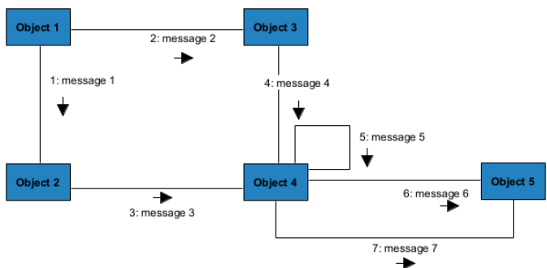
Figure 12 Communication diagram formalism

Components of a communication diagram
Table 14 components of a communication diagram
ELEMENT | NOTATION DESCRIPTION
Message |  | Designs a particular Communication between lifelines.
Connectors |  | It represents the relationships that exist between lifelines
Dependency | 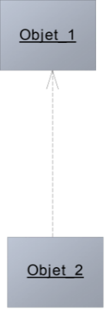 | A dependency is a relationship that signifies a single or a set of model elements for their  specification
Life line | 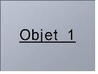 | An object represents an individual participant in the interaction conversation.

Diagrams
- Communication diagram of authenticate
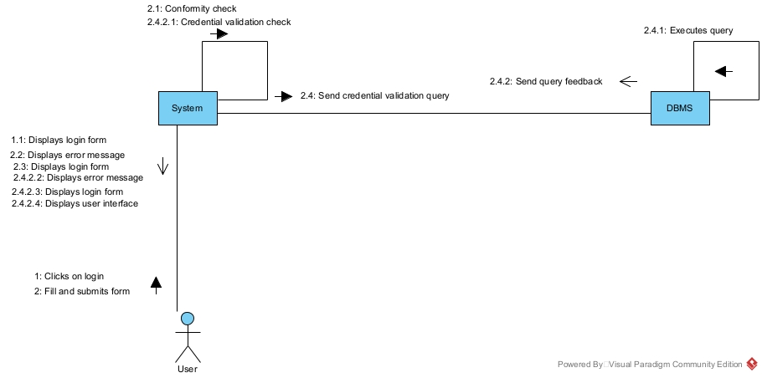
Figure 13 Communication diagram of authenticate
- Communication diagram of scan QR code
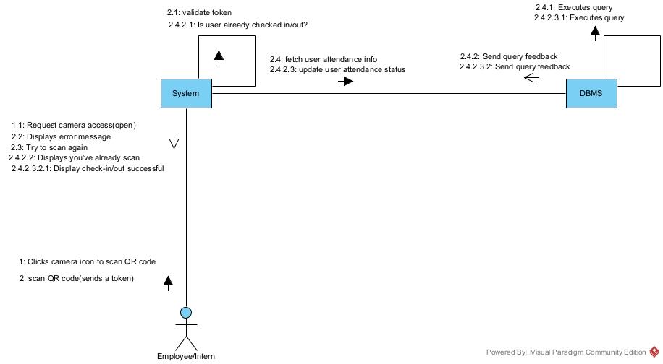
Figure 14 Communication diagram of Scan QR code
- Communication diagram of create task
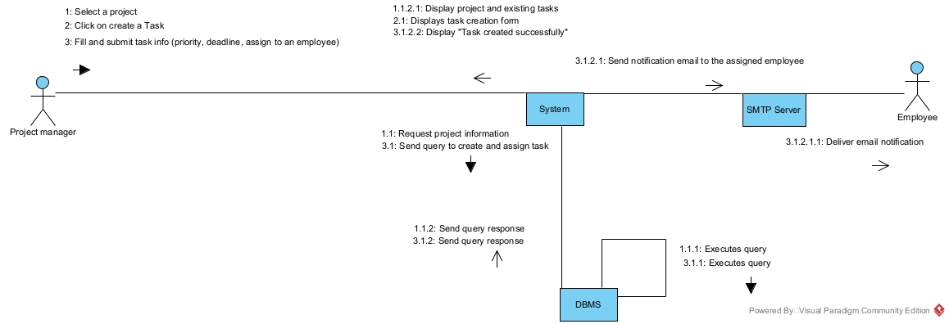
Figure 15 Communication diagram of create task

Sequence diagram

Definition
A sequence diagram is an interaction diagram which represents the flow of message between elements in a system, it is termed as an event diagram. It portrays the communication between any two lifelines as a time-ordered sequence of events.

Formalism
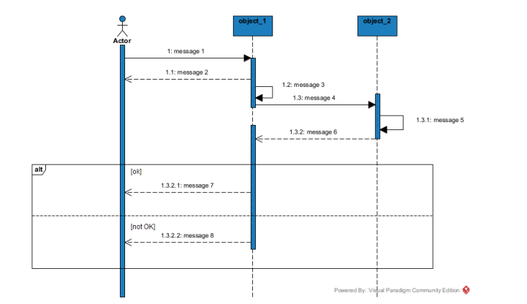
Figure 16 Sequence diagram formalism

Components of a sequence diagram
Table 15 Sequence diagram components
ELEMENTS | NOTATION | DESCRIPTION
Lifeline | 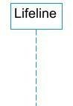 | An individual participant in a sequence diagram, it is position at the top of the diagram.
Combined fragment | 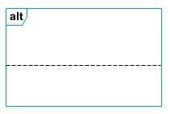 | It represents a choice of behavior in which at most one operand will be chosen.
Messages | 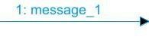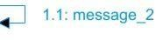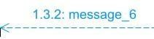 | These are arrows, which shows the direction of message flow. We have the synchronous, the asynchronous and the self-messages.
Activation | 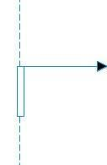 | It describes the time period in which an operation is performed by an element.

Diagrams
- Authentication Sequence
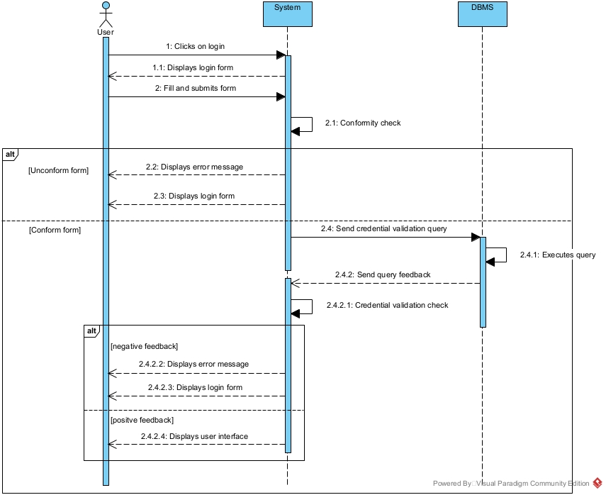
Figure 17 Authenticate Sequence

- Scan QR code Sequence
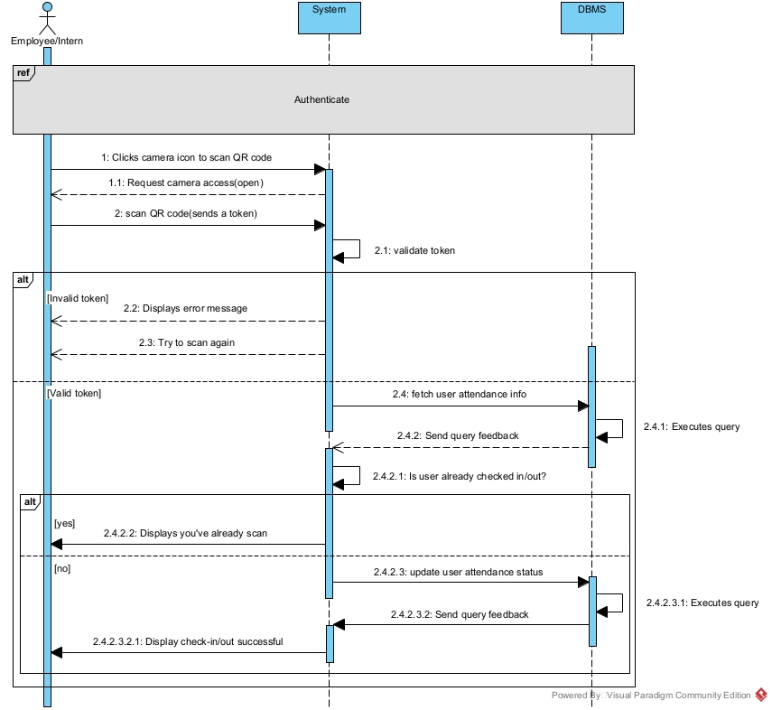
Figure 18 Scan QR code Sequence

- Create Task Sequence
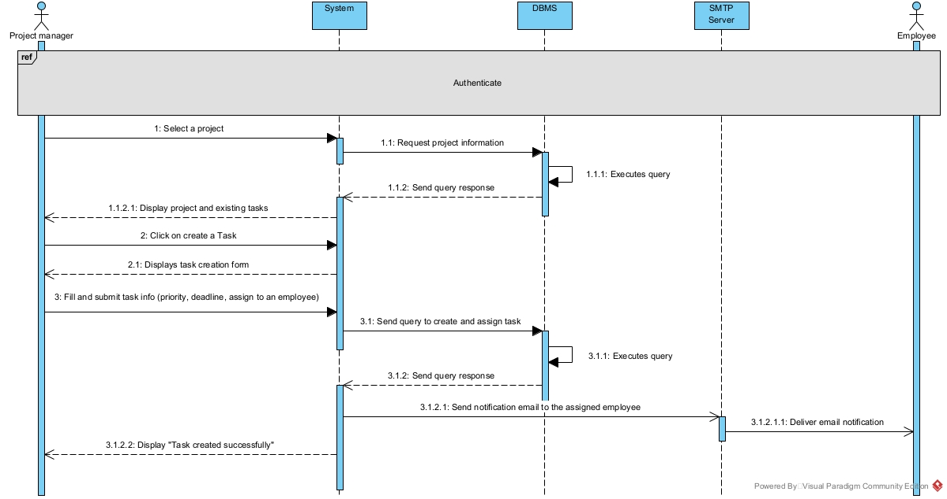
Figure 19 Create task Sequence

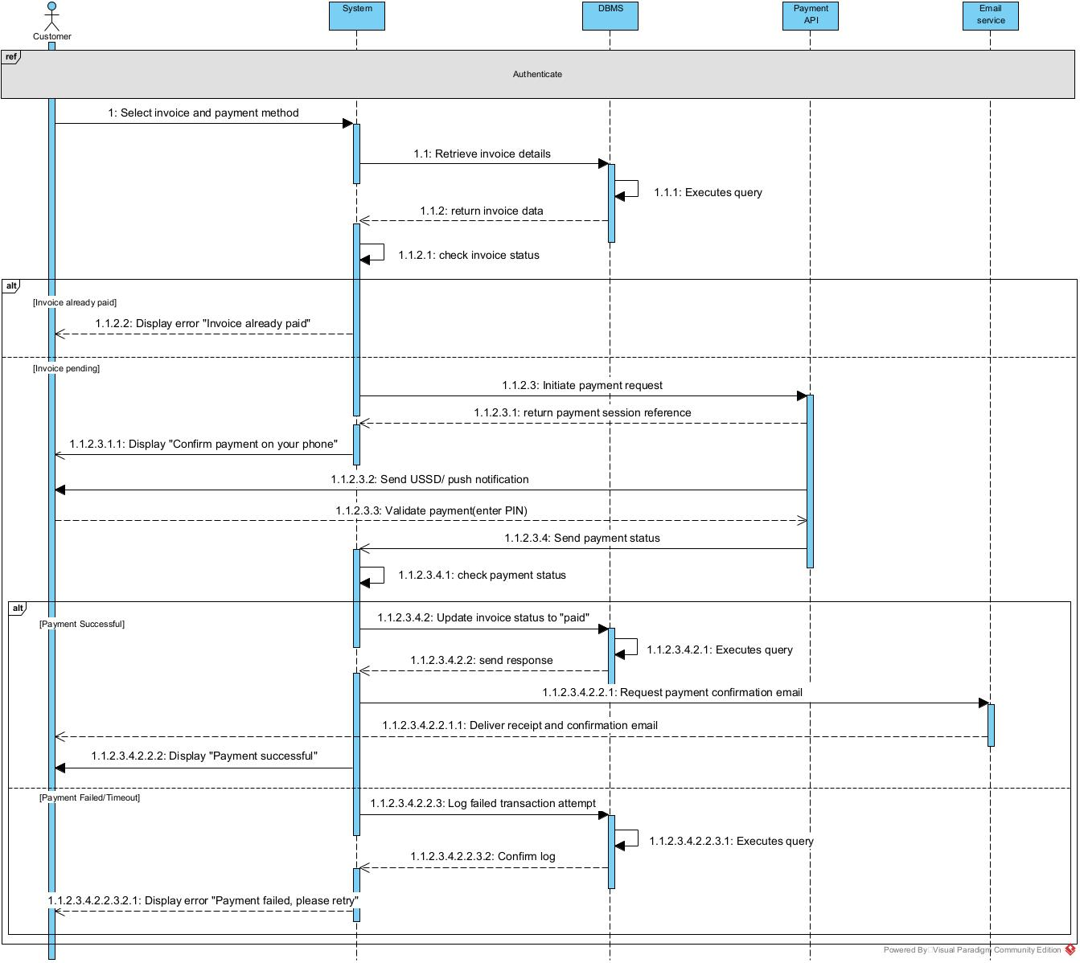
- Make payment
Figure 20 make payment sequence

Activity Diagram

Definition
An activity diagram is a graphical representation of work-flows that show the steps needed in the realization of a process; showing the details from a start point to an end point through all decisions and actions that can possible be performed. Activity diagrams are intended to model both the computational and organizational process. They flow can be sequential, branched or concurrent. Below is an activity diagram formalism.

Formalism
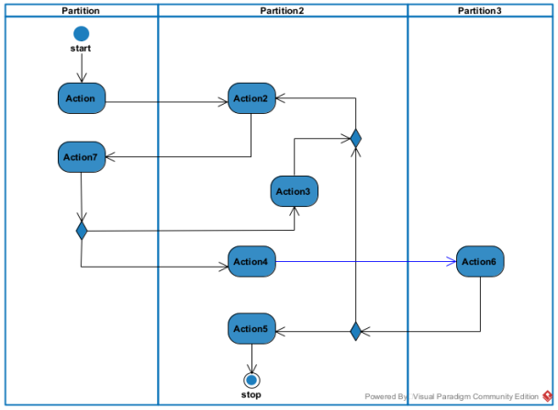
Figure 21 Formalism of activity diagram

Component of an activity diagram
Table 16 Elements of an activity diagram
Element Representations |  | Description
Activity | 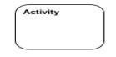 | Used to represent a set of actions.
Action | 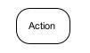 | Represent a task to be performed.
Activity edge |  | A directed connection between two activity nodes through which tokens may flow
Initial node |  | Shows the beginning of an activity or set of actions.
Final node |  | Stops all controls and object flows in an activity.
Object node | 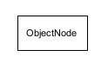 | Represents an object connected to a series of object flows.
Décision node | 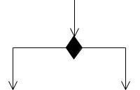 | Represents a test condition that slits an incoming activity edge into opposite outgoing activity edges.
Merge node | 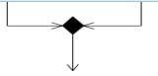 | Reunite different decision paths created using a decision node.
Fork node | 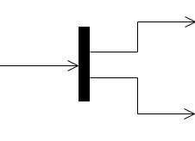 | Slit’s behavior into parallel or concurrent flows of activities (or actions).
Join node | 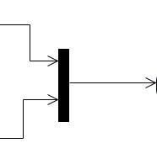 | Unites a set of parallel or concurrent flows of activities or actions.
Swimlane and partition | 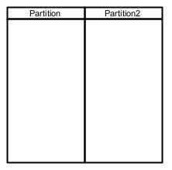 | A way of grouping activities performed by the same actor in an activity diagram or to group actions in the  same thread

Diagrams
- Login activity
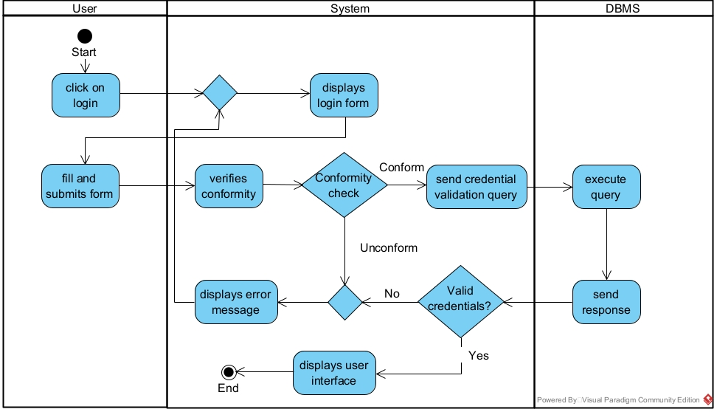
Figure 22 Login activity
- Scan QR Code activity
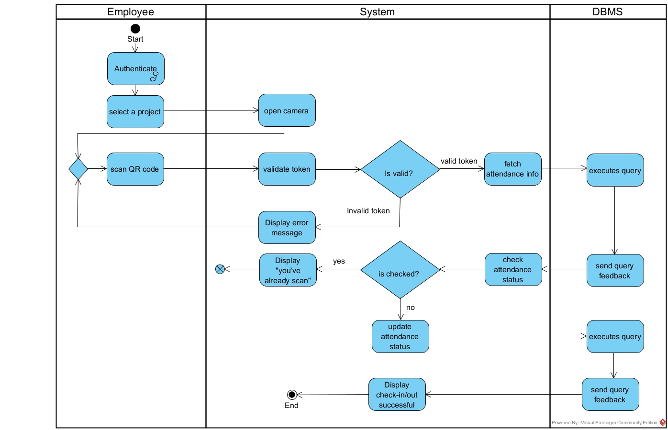
Figure 23 Scan QR code activity

- Create task activity
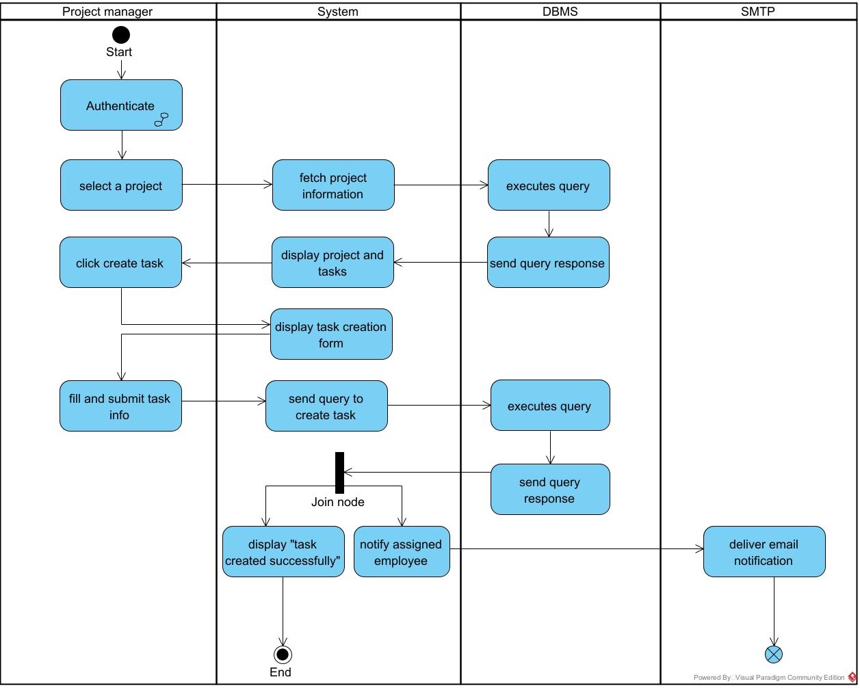
Figure 24 create task activity

CONCLUSION
In the analysis phase, we chose a software development process and modelling language, after which we presented the existing system, its limitation and our proposed solutions. We went forth explaining the functional need of our system, we saw the use case diagram which shows the relationship between the actors and use case (the action the actor can perform on the system), we saw the activity diagram which shows the workflow of our system, and lastly the State machine diagram which shows the behavior of a single object in response to an event. We will now move to the conception phase in which we will present the other two branches of the 2TUP which are the Technical and the realization branch of our system.

FILE IV: THE DESIGN FILE

Preamble
The conception phase will permit us to present in an orderly manner the components necessary for the good functioning of our software and also the architecture used for the proposed solution. It bridges the gap between the analysis phase and the realization phase

Content overview
INTRODUCTION
- THE ARCHITECTURE OF THE APPLICATION
- RELATED UML DIAGRAMS
  - Class Diagram
  - Object Diagram
  - State Machine Diagram
  - Package Diagram
CONCLUSION

INTRODUCTION
The conceptual phase will describe in detail the necessary specifications, features and operations that will satisfy the functioning requirements of the proposed system as modelled in the analysis phase. This phase is meant to identify and consider essential components (hardware /or software), structure (network capabilities), processes and procedures for the system to accomplish it objectives. We will look at some diagrams such as the component diagram, package diagram, communication diagram, class diagram and the object diagram.

THE ARCHITECTURE OF THE APPLICATION
A system Architecture is a conceptual model that defines the structure, behavior, and more views of a system. The system architecture can consist of system components and sub-systems developed that will work together to implement the overall system.

Physical Architecture
The design of the DBMS depends on its architecture. An n-tier architecture partitions on the whole system into related but separated n modules, which can be independently modified, altered, changed or replace. A large amount of data on web servers, personal and others are link with networks with the help of basic client or server architecture.
Within the scope of our project, we made use of the multi-tier architecture This architecture separate it tiers from each other based upon the user and the manipulated data in the database. It is important to note that with the multi-tier architecture, only neighboring layers can communicate. Each layer has a well-defined communication interface, and the evolution of the layer is independent of the other. The multi-tier of our system is made up of:
- The client tier, which is also known as our presentation tier.
- Application Tier, which represents our server where the business logic exists.
- The data tier, which runs on a database server
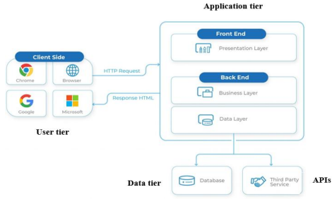
Figure 25 Physical Architecture

Logical Architecture
Model View Controller or MVC as it is popularly called, is a software development design pattern for developing application. A model view controller pattern is made up of the following three parts.
- Model: The lowest level of the pattern which is responsible for maintaining data.
- View: This is responsible for displaying all or a portion of data to the user.
- Controller: It hands software codes that controls the interactions between the model and the view.
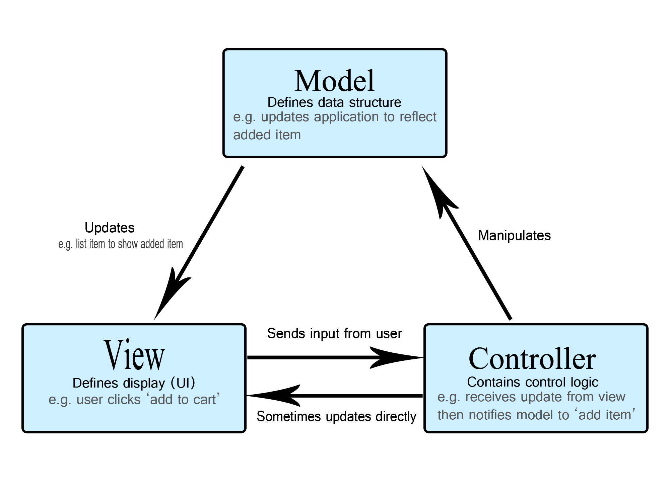
MVC is popular as it isolates the application logic from the user interface and supports separation of concerns. Here the controller receives all requests for the application then works with the model to prepare data needed by the view. The view then uses the data prepared by the controller to produce a final response. The MVC can be represented as follows:
Figure 26 MVC Architecture

RELATED UML DIAGRAMS

Class Diagram

Definition
A class diagram is a static diagram. It represents the static view of an application. class diagram is not only used for visualizing, describing and documenting different aspect of the system but also for constructing executable code of the software application. Class diagram describes the attribute and operation of a class and constraints imposed on the system. Its purpose is to model the static view of an application.

Formalism
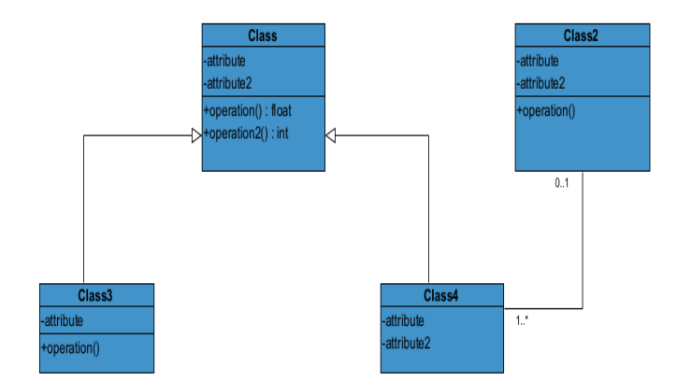
Figure 27 Class diagram formalism

Class diagram components
Table 17 Elements of the class diagram
Element | Representation | Description
Class | 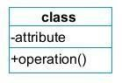 | A class is an element that defines the attributes and behaviours that an object is able to generate
Composition | 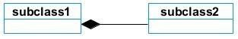 | If a parent of a composite is deleted, usually, all of its parts are deleted with it.
Aggregation |  | If the parent of the aggregate is deleted, usually the children are not del.
Dependency | 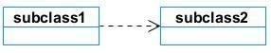 | It existed between two classes, if one changes it may cause the change in the order, but the other way around.
Generalization | 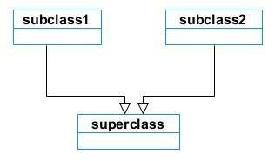 | It is a type of relationship between two classes where one class (child class) inherits the properties of the other class (parent class).
Association | 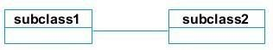 | It is a general type of relationship between elements, it may include cardinality, roles etc.

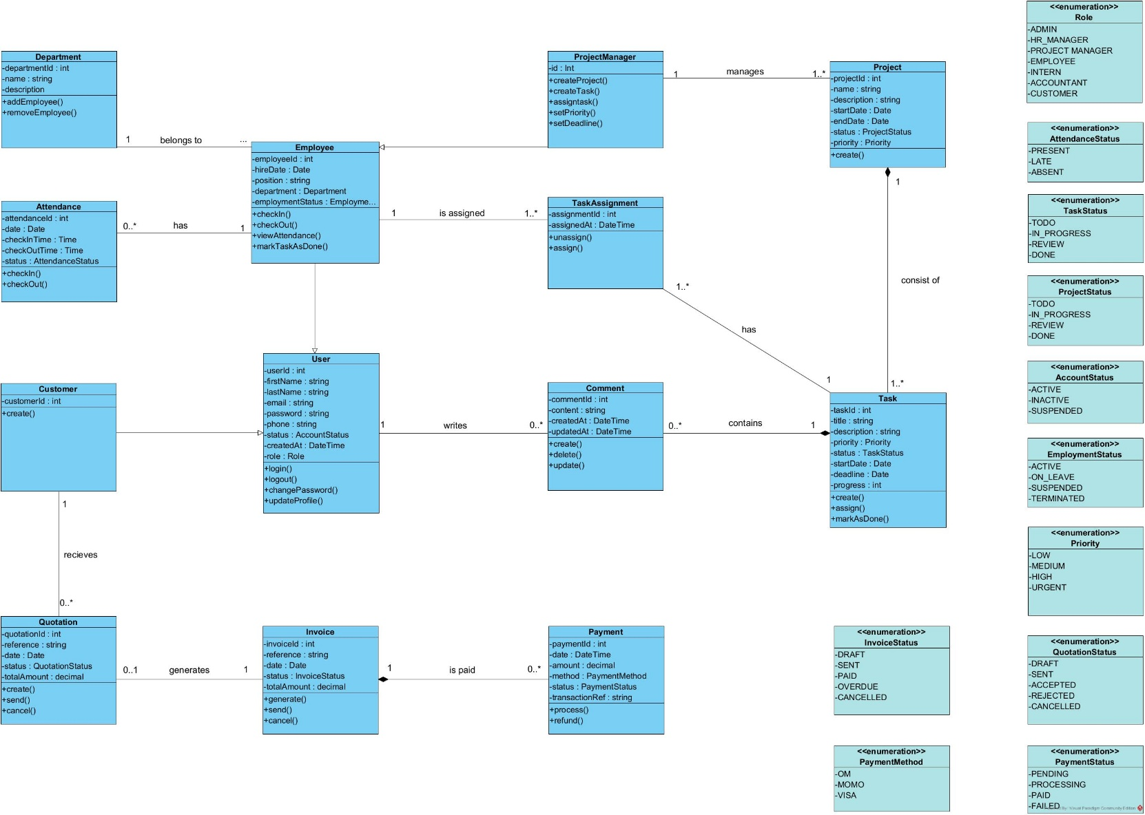
Class diagram
Figure 28 Class diagram

Object diagram

Definition
Object diagram represents an instance of a class diagram. It represents the static view of a system but this static view is a snapshot of the system at a particular moment. They are used to render a set of objects and their relationship as an instance.

Formalism

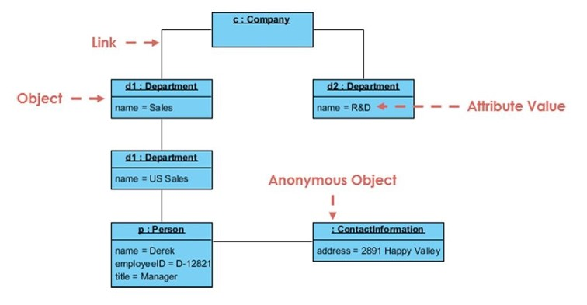

Figure 29 Object diagram formalism

Components of object diagram
Element | Representation | Description
Object Names | 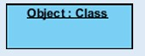 | Every object is represented as a rectangle that shows the name of the object and its class, underlined and separated with a colon.
Object Attributes | 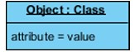 | Similar to classes, you can list object attributes inside a separate compartment. Unlike classes, object attributes must have values assigned.
Links | 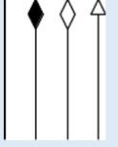 | Links are instances of associations. They are drawn using the same lines as in class diagrams.

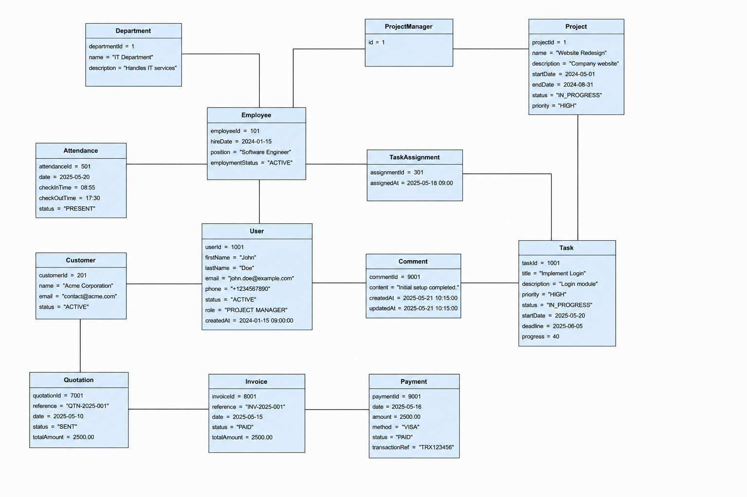
Object diagram
Figure 30 Object diagram

State machine Diagram

Definition
A state machine diagram describes the behaviour of a single object in response to a series of events in a system. Also known as the state machine diagram, it models the dynamic flow of control from the state of a particular object within a system.

Formalism
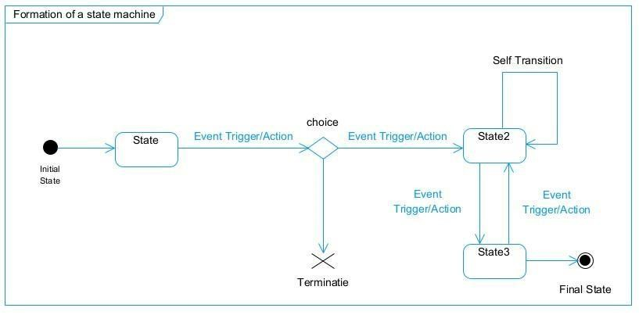
Figure 31 Formalism of a state machine diagram

Components of a state machine diagram
Table 18 Elements of a state machine diagram
Elements | Notation | Description
State | 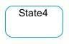 | Models a situation during which a certain invariant condition holds.
First (Initial) State |  | It represents a default vertex, that is, a source for a single transaction to the default or composite state.
Final State |  | A state specifying that the enclosing region is complete.
Transition | 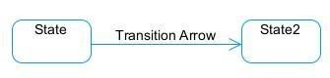 | A direction relation between a source and a target vertex.
Choice pseudo State |  | A diamond symbol that indicates a dynamic condition with branched potential results
Terminate | 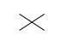 | Implies that the execution of a state by means of it context is terminated.
Diagram Overview | 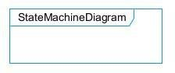 | A placeholder for the linked states in a state machine diagram.

State machine diagrams
- User Account state
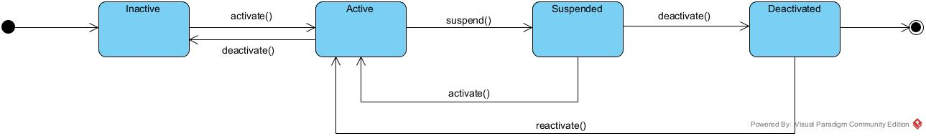
Figure 32 User account state machine diagram
- Comment state
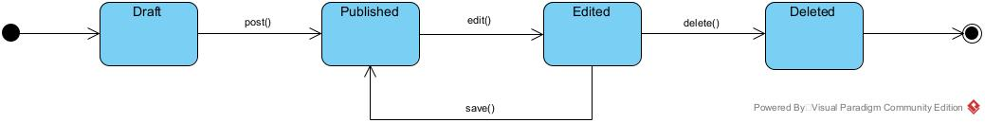
Figure 33 Comment state machine
- Make payment state
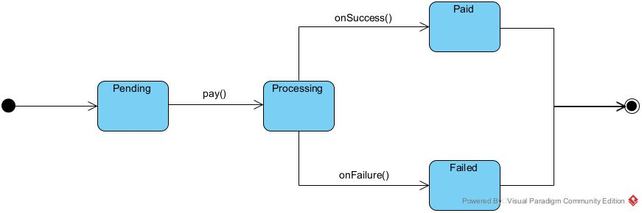
Figure 34 make payment state machine

Package Diagram

Definition
This is a structural diagram used to show the organization and arrangement of various model elements in the form of packages. A package diagram is the grouping of related uml elements such as classes, diagrams or eve other packages.

Formalism
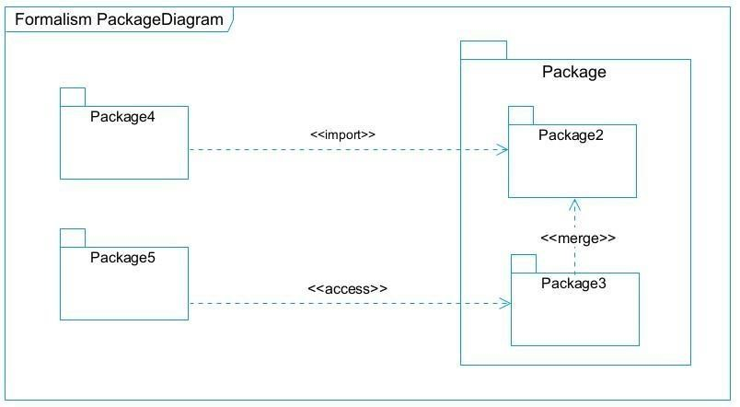
Figure 35 Formalism of package Diagram

Components of a package diagram
Table 19 Elements of a package diagram
Name | Representation | Description
Package | 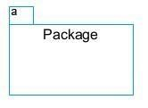 | A package is a namespace use to group related elements; it is a mechanism used to group elements into a better structure in a system.
Package import | 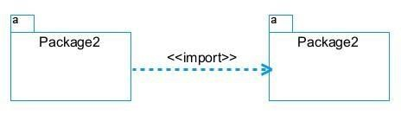 | A relationship Indicate that, functionality has been imported from one package to another.
Package Access | 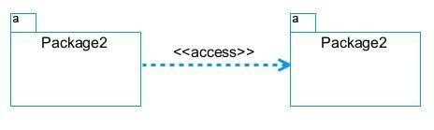 | A relationship Indicates that one package requires assistance from the function of another package.
Package merge | 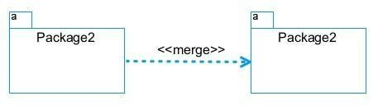 | It is a relationship which shows that, the functionality of two packages are combines to a single function.

Package diagram of the system
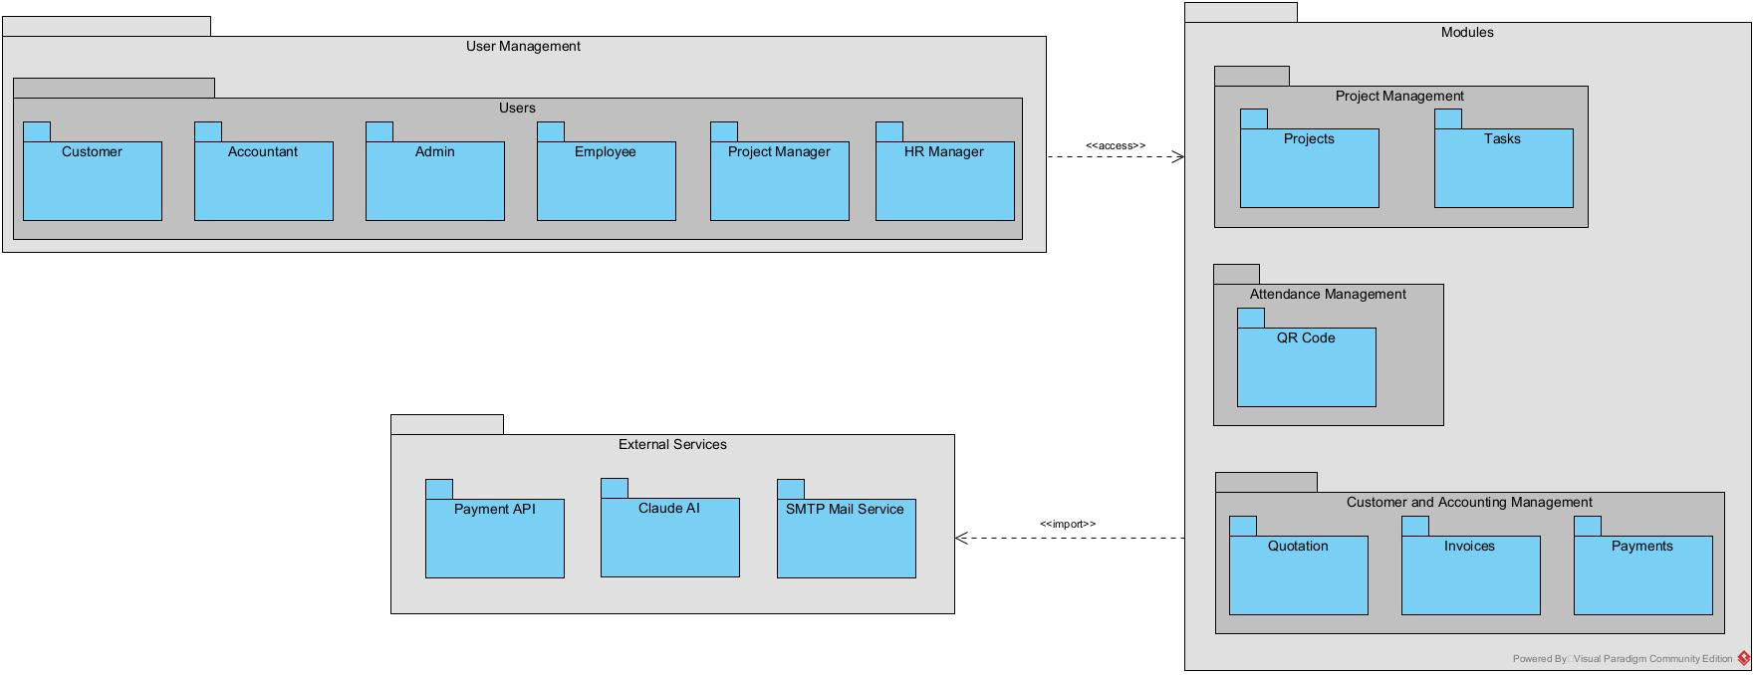
Figure 36 Package diagram

CONCLUSION
In the conception phase, we set as objective to plane the different aspect of our system by showing how it will be structure and deployed within existing technical architectures. We began by taking into account the technical constraints for our system, after which we proceeded to identify the components of our system, how they are grouped together and how they should be deployed on appropriate deployment targets. We finished this phase by looking at interactions between the various aspects and actors of our system. The next phase of our report is the realization phase where we will look at aspects concerning the implementation of our system.

FILE V: THE DEPLOYMENT FILE

Preamble
This section of our report will cover details on the product to be delivered with the agreement of the client(s) and the solution provider. In this section, we are going to present the context in which we are to put in place a platform, what the system should do and how the system should do it.

Content Overview
INTRODUCTION
- PRELIMINARY CONCEPTION
  - Component Diagram
  - Deployment Diagram
- TECHNICAL CHOICES
CONCLUSION

INTRODUCTION
Here in the realization phase, we will concentrate on building or implementing our solution, based on the different analysis and conception that we had carried out, which will help to facilitate our work, this phase is as critical as the previous phases. We are going to look at the relationship that exist between the entities of the entity relational diagram. Furthermore, we will see the choices of technologies used for the implementation of our system.

PRELIMINARY CONCEPTION

Component diagram

Definition
Component diagrams are used to model the physical aspect of a system. Now the question is what are this physical aspect? They are elements such as Executables, libraries, files, document etc. which resides in a node. The component diagram does not opt describe the functionality of the system, but it describes the components used to make those functionalities

Formalism
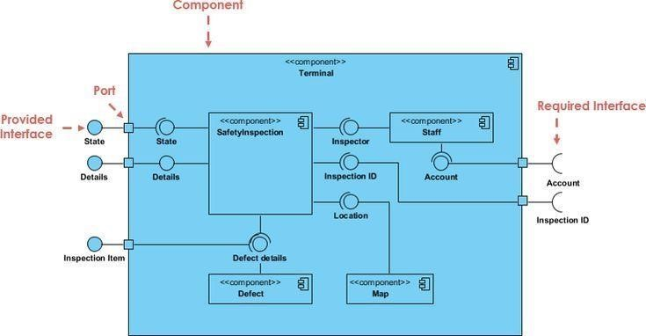
Figure 37 component diagram formalism

Elements of a component diagram
Table 20 Elements of a component diagram
NAME | REPRESENTATION | DESCRIPTION
A component | 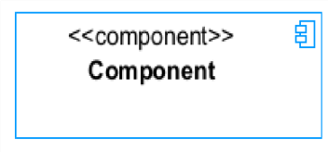 | A component is an abstract logical unit block of a system.it is represented as a rectangle with smaller rectangle in the upper right corner which saves as it icon for recognition.
Dependency | 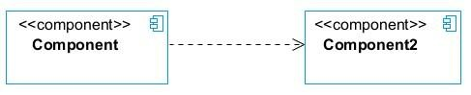 | Dependency is a directed relationship, which is used to show that some components are dependent on others for their correct functioning.
interface | 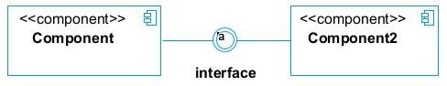 | An interface is a circle or a semicircle attached to a stick which looks like a lollipop. It describes groups of operations provided or required by components.
port | 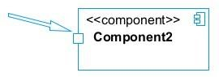 | A port (represented by a small square at the end of a required or provided interface) is used when the components delegate the interfaces to an internal class.

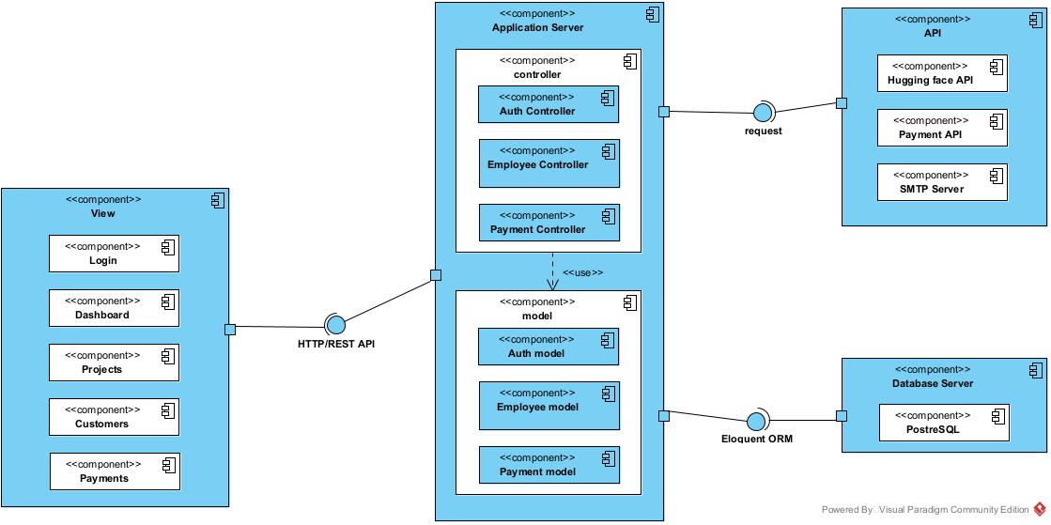
The component diagram of our system
Figure 38 Component diagram

Deployment diagram

Definition
A deployment diagram consists of nodes. Nodes are nothing but physical hardware used to deploy the application Deployment diagram is a structural diagram used to visualize the topology of the physical components of a system, where the software is deployed. They consist of nodes and their relationship. It is related to the component diagram because the components are deployed using the deployment diagram.

Formalism
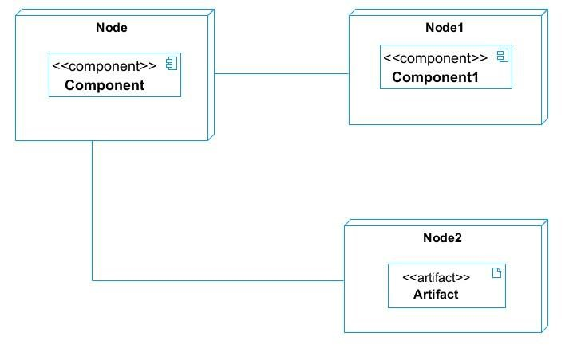
Figure 39 Formalism of deployment diagram

Elements of a deployment diagram
Element | Representation | Description
Node | Table 21 Elements of deployment diagram  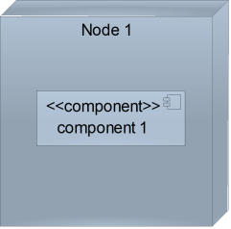 | It is a hardware used to deploy the application
Artifact | 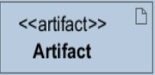 | An artifact is a major product, which is produced or used during the development of a software. E.g diagrams, data models, setup scripts
Component | 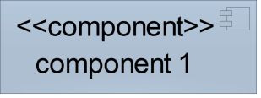 | It represents a modular part of a system that encapsulates its content and whose manifestation is replaceable within it environment.
Association | association | An association helps to connect two nodes together which permits them to communicate together

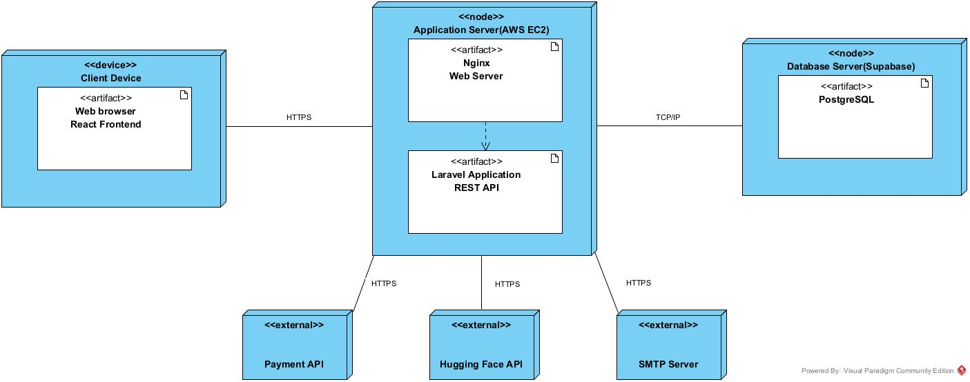
Deployment diagram
Figure 40 Deployment diagram

TECHNICAL CHOICES
A development tool is a hardware or software that supports the heartbeat implementation of software application that's used to create, debug, maintain, or otherwise support other programs and applications.

Material used for the development of our platform

Hardware
Material | Quantity | Function | Image
HP Victus Laptop | 1 | Used for software development, programming, system analysis, testing, and documentation of the ERP. | 

Software
Software | Role | Image
React.js | Development of the ERP front-end user interface. | 
Laravel / PHP | Development of the back-end and application logic. | 
PostgreSQL | Database management and storage of ERP data. | 
Visual Paradigm | Design and modeling of UML diagrams. | 
PhpStorm | Integrated development environment used for coding and project management. | 
Windows 11 | Operating system used as the development environment. | 
GitHub | Version control and hosting of the project's source code. | 
Word | Typing and drafting the report | 

CONCLUSION
In our realization phase, we set as objective to plane the different aspect of our system by showing how it will be structure and deployed within existing technical architectures. We began by considering the technical constraints for our system, after which we proceeded to identify the components of our system, how they are grouped together and how they should be deployed on appropriate deployment targets. We finished this phase by looking at interactions between the various aspects and actors of our system. The next phase of our report is the realization phase where we will look at aspects concerning the implementation of our system.

FILE VI: FUNCTIONALITY TEST

